PINAKI CHOUDHURI
ROLL: CSF(012) AU/2023/0009351
SUB: UNSTRUCTURED DB

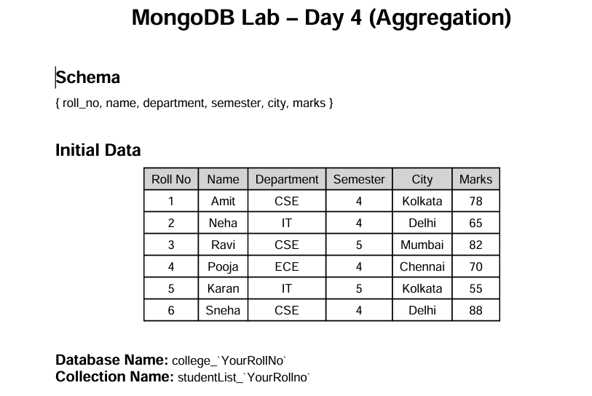

Lab Questions Q1. Display all student records using aggregation

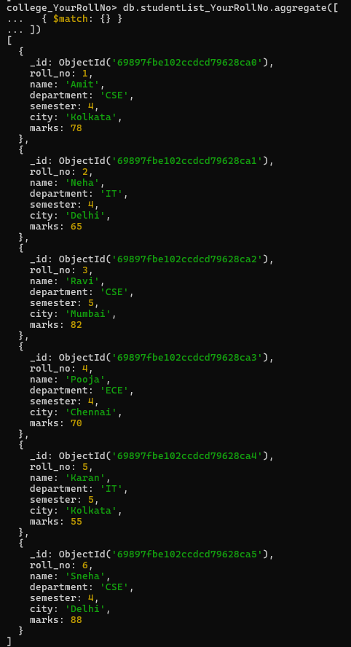

Q2. Display students belonging to CSE department.
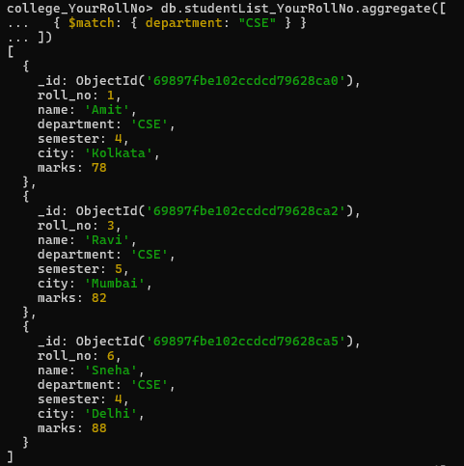

Q3. Display students of semester 4
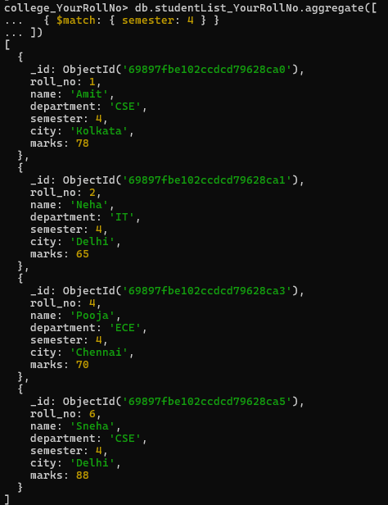

Q4. Display only name and marks of all students
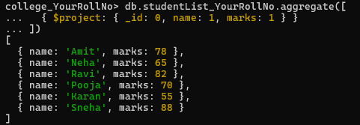

Q5. Find the average marks of all students.

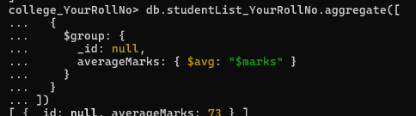
Q6. Find total marks scored department-wise

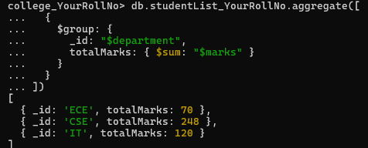
Q7. Find average marks department-wise.

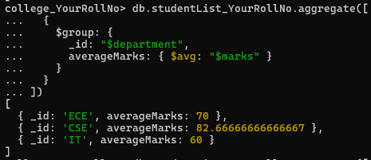

Q8. Find maximum marks scored in each department.
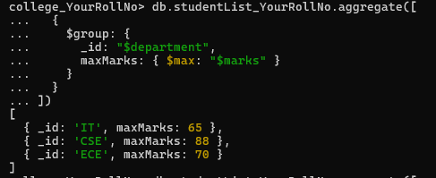
Q9. Count number of students in each department.

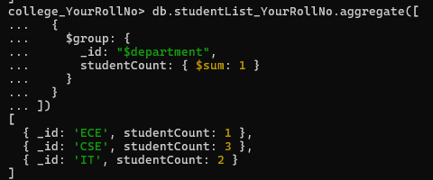

Q10. Display departments having average marks greater than 70

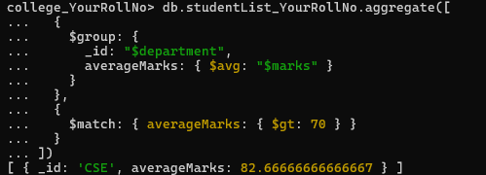
Q11. Sort students by marks in descending order

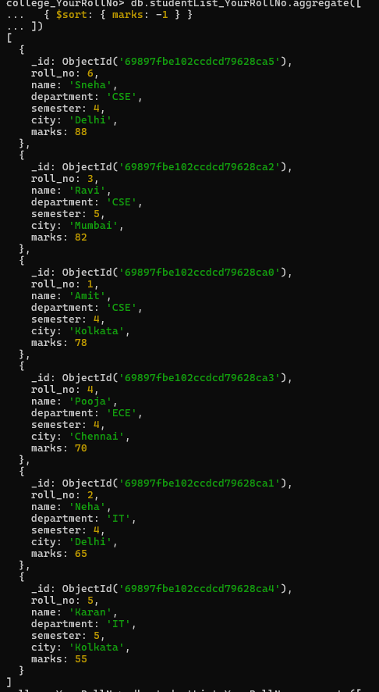
Q12. Display top 3 students based on marks.
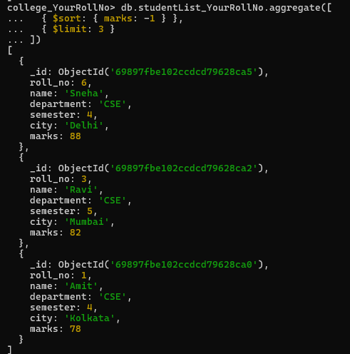
Q13. Display department-wise average marks sorted in descending order.

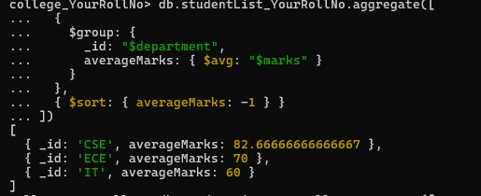

Q14. Display students belonging to Delhi or Kolkata
